# Merrick Solutions Workflow Planner

The Merrick Solutions Workflow Planner App-Pack assists in prioritizing build order based on the build effort to add Advanced Workflow (AWF) to existing or new applications. The assessment questions and weightings provide a consistent evaluation of effort.  Weightings are based on a single configuration. The application allows you to list out applications/questionnaires by name to ease report generation and generate side by side comparisons of build efforts. Application reports encompass both the rating process as well as displaying the results in recommended build order. This offering is intended for Archer Admins for use in the Development environment.

On this page

* Release notes
* Overview
  + Key Benefits and Features
  + Prerequisites (ODA and system requirements)
  + Compatible Use Cases and Applications
    - Related Applications
    - Impacted Use Case(s)
  + Swim lane diagram
  + Applications
  + Personas and Access Roles
* Installing Merrick Solutions Workflow Planner App-Pack
  + Installation overview
    - Step 1: Prepare for the installation
    - Step 2: Install the package
    - Step 3: Test the Installation
  + Installing the Package
    - Task 1: Back up your database
    - Task 2: Import the package
    - Task 3: Map objects in the package
    - Task 4: Install the package
    - Task 5: Review the package installation log
* Using Merrick Solutions Workflow Planner App-Pack
  + Task 1: Add record to AWF Planner application
  + Task 2: Generate Assessment
  + Task 3: Complete Assessment
* Certification environment

## Release notes

| Release date | Release version | Notes |
| --- | --- | --- |
| February 2024 | 6.14 P2 | Initial release |

## Overview

### Key Benefits and Features

With the offering, you will be able to:

* Leverage Assessment questions as development and scoping guidelines.
* Provides consistent and quantitative feedback for build effort decisions.
* Easily expandable to handle new AWF (or AWF- adjacent) features.

The key features include:

* Prebuilt Assessment with guiding questions and scoring weightings based on real world data from multiple builds, solutions, and business verticals.
* Applicable to both new and existing applications/questionnaires
* Scoring Weightings are configurable based on resources.
* Sample AWF containing notes on basic node usage.

### Prerequisites (ODA and system requirements)

| Components | Prerequisites |
| --- | --- |
| Archer Solution Area(s) | Any |
| Archer Use Case(s) | Any |
| Archer Applications | Any |
| Uses Custom Application | Yes |
| Requires On-Demand License | One (1) Archer On-Demand License is required. |
| Archer Requirements | Archer 6.14 P2 and later |
| Partner/Vendor Requirements | Valid License is required |
| Operating System | Windows Server 2016 |
| Database Server | Microsoft SQL Server 2017 (64-bit) |
| Services Server | Java Runtime Environment (JRE) 8 (64-bit) |

### Compatible Use Cases and Applications

#### Related Applications

| Application | Use Case | Primary Purpose(s) of the Relationship |
| --- | --- | --- |
| N/A | Stand-alone ODA | N/A |

#### Impacted Use Case(s)

| Archer Use Case(s) |
| --- |
| N/A |

### Swim lane diagram

The Application process begins when a user creates a record. The user performs an assessment on the record to determine the weighted build effort score.

The following diagram shows the general workflow of the application.

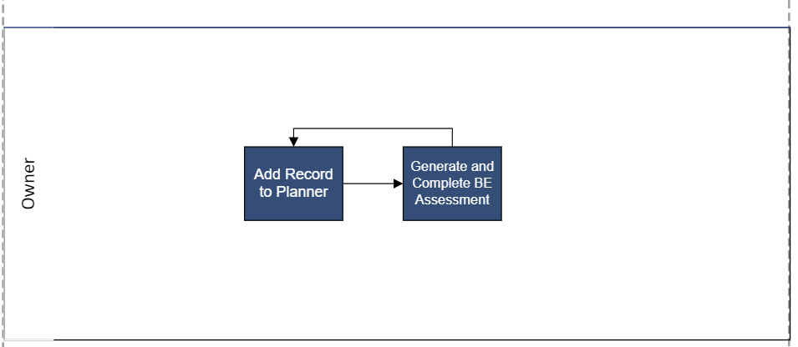

### Applications

| Application | Description |
| --- | --- |
| AWF Planner | ODA to capture applications/questionnaires for Build Effort Assessment and Build Order Prioritization |
| Build Effort Assessment | Assessment used to generate the Build Effort. |

### Personas and Access Roles

The following table describes the functions that make up the application’s organization roles. Depending on the organization of your company, these functions and responsibilities may vary.

| Function | Description |
| --- | --- |
| Owner | Inputs data, runs searches, and generates reports. |

## Installing Merrick Solutions Workflow Planner App-Pack

### Installation overview

#### Step 1: Prepare for the installation

1. Ensure that your Archer system meets the following requirements:
   * Archer Platform version 6.14 P2
2. Read and understand the "Packaging Data" section of the Archer Online Documentation.

#### Step 2: Install the package

Installing a package requires that you import the package file, map the objects in the package to objects in the target instance, and then install the package. See Installing the Application Package for complete information.

#### Step 3: Test the Installation

Test the application according to your company standards and procedures, to ensure that the use case works with your existing processes.

### Installing the Package

#### Task 1: Back up your database

There is no Undo function for a package installation. Packaging is a powerful feature that can make significant changes to an instance. Archer strongly recommends backing up the instance database before installing a package. This process enables a full restoration if necessary.

An alternate method for undoing a package installation is to create a package of the affected objects in the target instance before installing the new package. This package provides a snapshot of the instance before the new package is installed, which can be used to help undo the changes made by the package installation. New objects created by the package installation must be manually deleted.

#### Task 2: Import the package

1. Go to the Install Packages page.
   1. From the menu bar, click .
   2. Under Application Builder, click Install Packages.
2. In the Available Packages section, click Import.
3. Click Add New, then locate and select the package file that you want to import.
4. Click OK.

The package file is displayed in the Available Packages section and is ready for installation.

#### Task 3: Map objects in the package

**Important:** This step is required only if you are upgrading to a later version of [ODA name].

1. In the Available Packages section, select the package you want to map.
2. In the Actions column, click  for that package.

The analyzer runs and examines the information in the package. The analyzer automatically matches the system IDs of the objects in the package with the objects in the target instances and identifies objects from the package that are successfully mapped to objects in the target instance, objects that are new or exist but are not mapped, and objects that do not exist (the object is in the target but not in the source).

**Note:** This process can take several minutes or more, especially if the package is large, and may time out after 60 minutes. This time-out setting temporarily overrides any IIS time-out settings set to less than 60 minutes.

When the analyzer is complete, the Advanced Package Mapping page lists the objects in the package file and corresponding objects in the target instance. The objects are divided into tabs, depending on whether they are found within Applications, Solutions, Access Roles, Groups, Sub- forms, or Questionnaires.

1. On each tab of the Advanced Mapping Page, review the icons that are displayed next to each object name to determine which objects require you to map them manually.

| Icon | Name | Description |
| --- | --- | --- |
| Awaiting mapping review | Awaiting Mapping Review | Indicates that the system could not automatically match the object or children of the object to a corresponding object in the target instance.  Objects marked with this symbol must be mapped manually through the mapping process.  **Important:** New objects should not be mapped. This icon should remain visible. The mapping process can proceed without mapping all the objects.  **Note:** You can execute the mapping process without mapping all the objects. The Awaiting mapping review icon is for informational purposes only. |
| Checkmark | Mapping  Completed | Indicates that the object and all child objects are mapped to an object in the target instance. Nothing more needs to be done with these objects in Advanced Package Mapping. |
| Missing objects | Do Not  Map | Indicates that the object does not exist in the target instance or the object was not mapped through the Do Not Map option. These objects will not be mapped through Advanced Package Mapping and must be remedied manually. |
|  | Undo | Indicates that a mapped object can be unmapped. This icon is displayed in the Actions column of a mapped object or object flagged as Do Not Map. |

1. For each object that requires remediation, do one of the following:
   * To map each item individually, on the Target column, select the object in the target instance to which you want to map the source object. If an object is new or if you do not want to map an object, select Do Not Map from the drop-down list.
   * **Important:** Ensure that you map all objects to their lowest level. When objects have child or related objects, a drill-down link is provided on the parent object. Child objects must be mapped before parent objects are mapped. For more details, see "Mapping Parent/Child Objects" in the Archer Online Documentation.
   * To automatically map all objects in a tab that have different system IDs but the same object name as an object in the target instance, do the following:
   1. In the toolbar, click Auto Map.
   2. Select an option for mapping objects by name.

| Option | Description |
| --- | --- |
| Ignore case | Select this option to match objects with similar names regardless of the case of the characters in the object names. |
| Ignore spaces | Select this option to match objects with similar names regardless of whether spaces exist in the object names. |

* 1. Click OK. The Confirmation dialog box opens with the total number of mappings performed. These mappings have not been committed to the database yet and can be modified in the Advanced Package Mapping page.
  2. Click OK.
     + To set all objects in the tab to Do Not Map, in the toolbar, click Do Not Map.
     + **Note:** To undo the mapping settings for any individual object, click  in the Actions column.
  3. When all objects are mapped, the Checkmark icon is displayed in the tab title. The Missing objects icon is displayed next to the object to indicate that the object will not be mapped.
  4. Verify that all other objects are mapped correctly.
  5. (Optional) To save your mapping settings so that you can resume working later, see "Exporting and Importing Mapping Settings" in the Archer Online Documentation.
  6. Once you have reviewed and mapped all objects, click .
  7. Select I understand the implications of performing this operation and click OK.
  8. The Advanced Package Mapping process updates the system IDs of the objects in the target instance as defined on the Advanced Package Mapping page. When the mapping is complete, the Import and Install Packages page is displayed.
  + **Important:** Advanced Package Mapping modifies the system IDs in the target instance. Any Data Feeds and Web Service APIs that use these objects will need to be updated with the new system IDs.

#### Task 4: Install the package

All objects from the source instance are installed in the target instance unless the object cannot be found or is flagged to not be installed in the target instance. A list of conditions that may cause objects not to be installed is provided in the Log Messages section. A log entry is displayed in the Package Installation Log section.

1. Go to the Install Packages page.
   1. From the menu bar, click .
   2. Under Application Builder, click Install Packages.
2. In the Available Packages section, locate the package file that you want to install, and click Install.
3. In the Configuration section, select the components of the package that you want to install.
   * To select all components, select the top-level checkbox.
   * To install only specific global reports in an already installed application, select the checkbox associated with each report that you want to install.
   * **Note:** Items in the package that do not match an existing item in the target instance are selected by default.
4. In the Configuration section, under Install Method, select an option for each selected component. To use the same Install Method for all selected components, select a method from the top-level drop-down list.

* **Note:** If you have any existing components that you do not want to modify, select Create New Only. You may have to modify those components after installing the package to use the changes made by the package.

1. In the Configuration section, under Install Option, select an option for each selected component. To use the same Install Option for all selected components, select an option from the top-level drop-down list.

* **Note:** If you have any custom fields or formatting in a component that you do not want to lose, select Do not Override Layout. You may have to modify the layout after installing the package to use the changes made by the package.

1. To deactivate target fields and data-driven events that are not in the package, in the Post-Install Actions section, select the Deactivate target fields and data-driven events that are not in the package checkbox. To rename the deactivated target fields and data-driven events with a user-defined prefix, select the Apply a prefix to all deactivated objects checkbox, and enter a prefix. This can help you identify any fields or data-driven events that you may want to review for cleanup post-install.
2. Click Install.
3. Click OK.

#### Task 5: Review the package installation log

1. Go to the Package Installation Log tab of the Install Packages page.
   1. From the menu bar, click .
   2. Under Application Builder, click Install Packages.
   3. Click the Package Installation Log tab.
2. Click the package that you want to view.
3. In the Package Installation Log page, in the Object Details section, click View All Warnings.

## Using Merrick Solutions Workflow Planner App-Pack

### Task 1: Add record to AWF Planner application

1. [Open AWF](javascript:void(0);) Planner application.
2. Click Add New.
3. Click Save.

### Task 2: Generate Assessment

1. [Open AWF](javascript:void(0);) Planner application.
2. Open the record that needs to be assessed.
3. Click Add New on the Build Effort Assessments field.

### Task 3: Complete Assessment

1. Open Build Effort Assessments
2. Open the assessment that needs to be completed.
3. Complete and Save the Assessment

## Certification environment

Date tested: January 2024

| Product name | Version information | Operating system |
| --- | --- | --- |
| Archer | 6.14 P2 | Windows |